LAB SESSION 06
Objective: - To analyze the phenomenon of drift of charge carriers under the influence of electric field.
TASK 1

Apply potential across an intrinsic semiconductor
Q.1: - From the simulation results determine doping, electron and hole density at equilibrium. Don’t forget to attach simulation results.
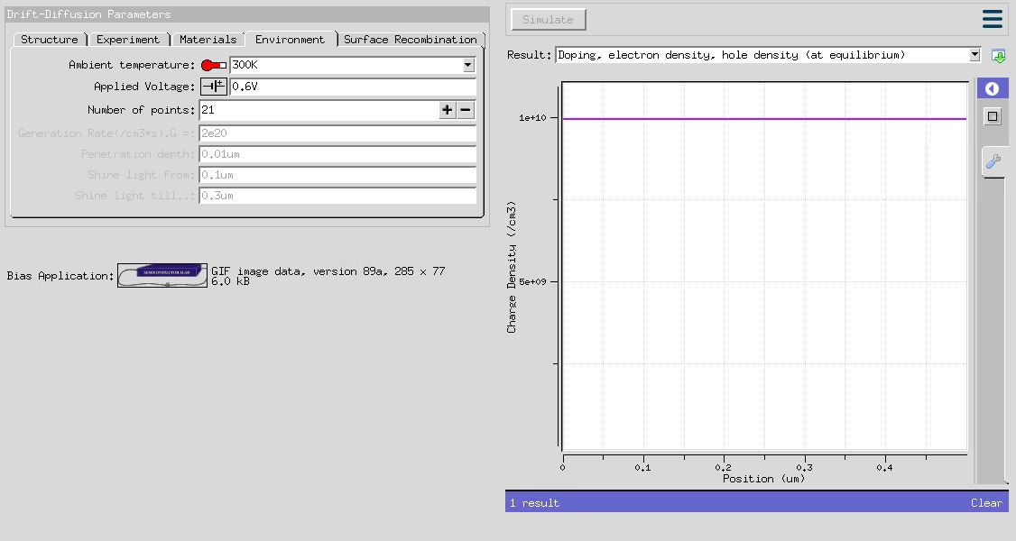

Q.2: - What is the current density when 0.18V is applied across the semiconductor. Verify the simulation results by mathematical calculation.

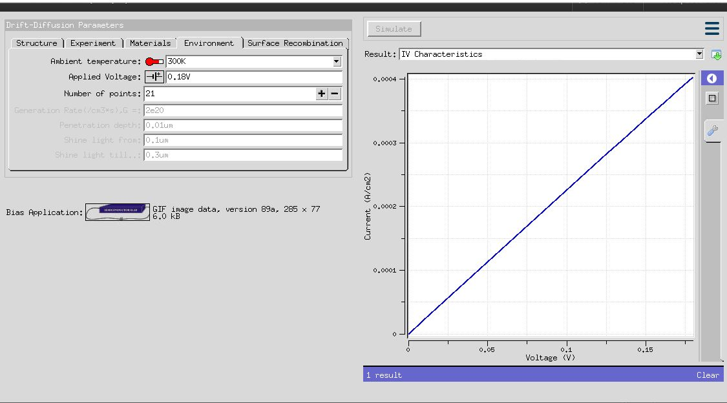

MATHEMATICAL CALCULATION:

J_{drift} = (U_{n}+U_{p})n_{i}qE
J_{drift} = (1350+480)*( 10¹⁰)*(1.6x10⁻¹⁹)*(0.18 / 13x10⁻⁴)
J_{drift} = 4.05x10⁻⁴ A/cm²
The simulation results and mathematical calculation result both are same.

Task No.02: - Apply potential across an n-type semiconductor:
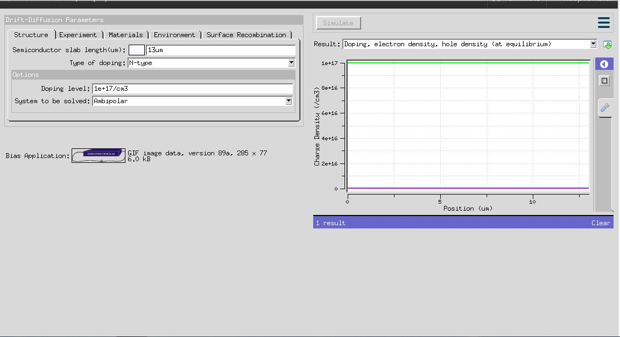
Q.1: - From the simulation results determine doping, electron and hole density at equilibrium. Don’t forget to attach simulation results.

Q.2: - What is the current density when 0.18V is applied across the semiconductor. Verify the simulation results by mathematical calculation.
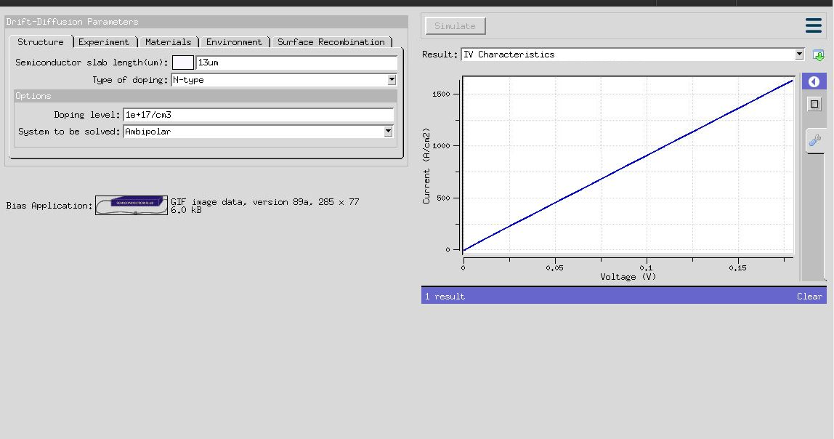
MATHEMATICAL CALCULATION:

J_{drift} = U_{n}n_{i}qE
J_{drift} = (750)*( 10¹⁰)*(1.6x10⁻¹⁹)*(0.18 / 13x10⁻⁴)
J_{drift} = 1.66x10⁻⁴ A/cm²

The simulation results and mathematical calculation result both are same.

Task No.03: - Apply a potential across n-type semiconductor. Find out the current density. Now vary the doping and from the simulation results, observe the effect of doping on current density.
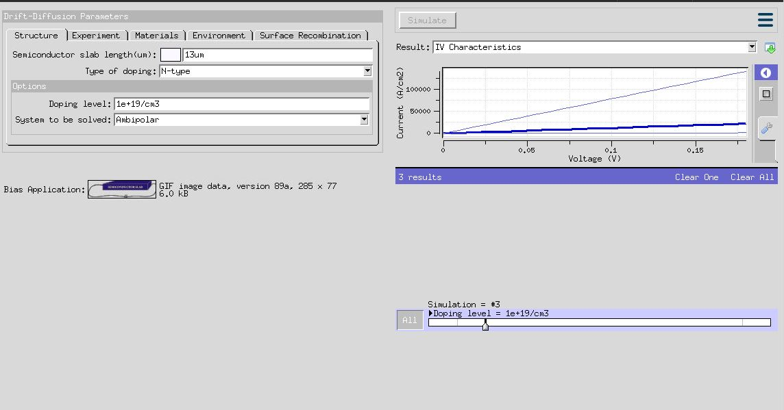

Task No.04: - Observe the effect of current saturation at high electric field in n-type semiconductor.
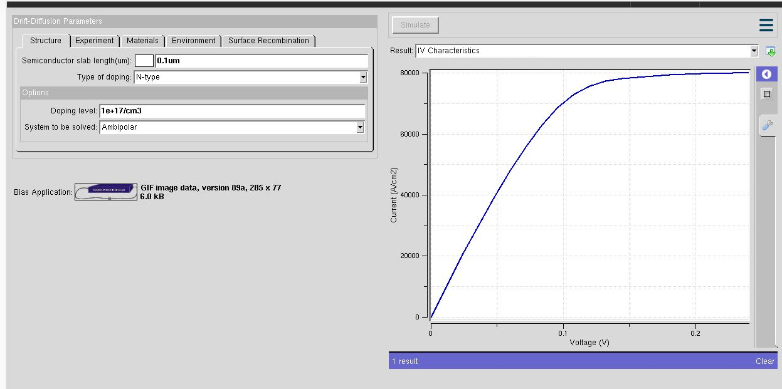

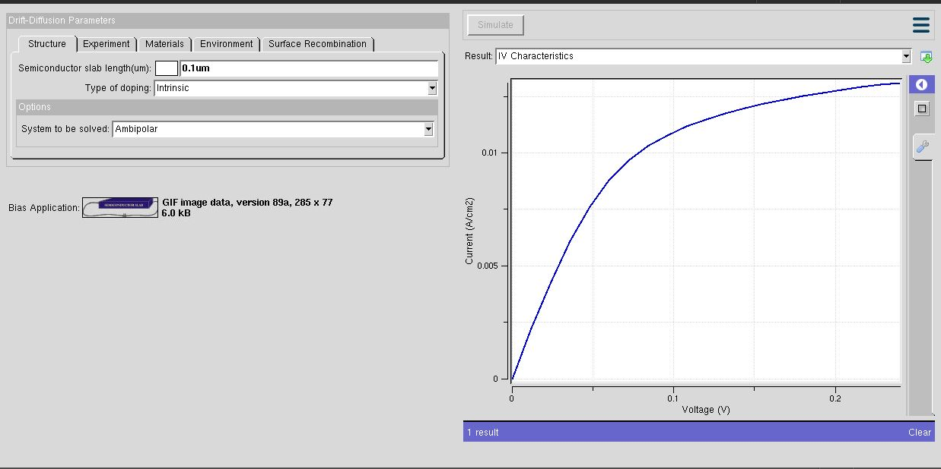
Task No.05: - Observe the effect of current saturation at high electric field in an intrinsic semiconductor.

